|  |  |
| --- | --- |
| EGC_Black | Student Name \_\_\_\_\_\_\_\_\_\_\_\_\_\_\_\_\_\_\_\_\_\_\_  **Eastern Goldfields College**  Mathematics Methods 2015  Test 311– Calculator Free Section |
| Working Time: 25 minutes | Total Marks: 20 marks |

**Question 1 [5 marks – 1, 4]**

Consider the two right triangles shown below.

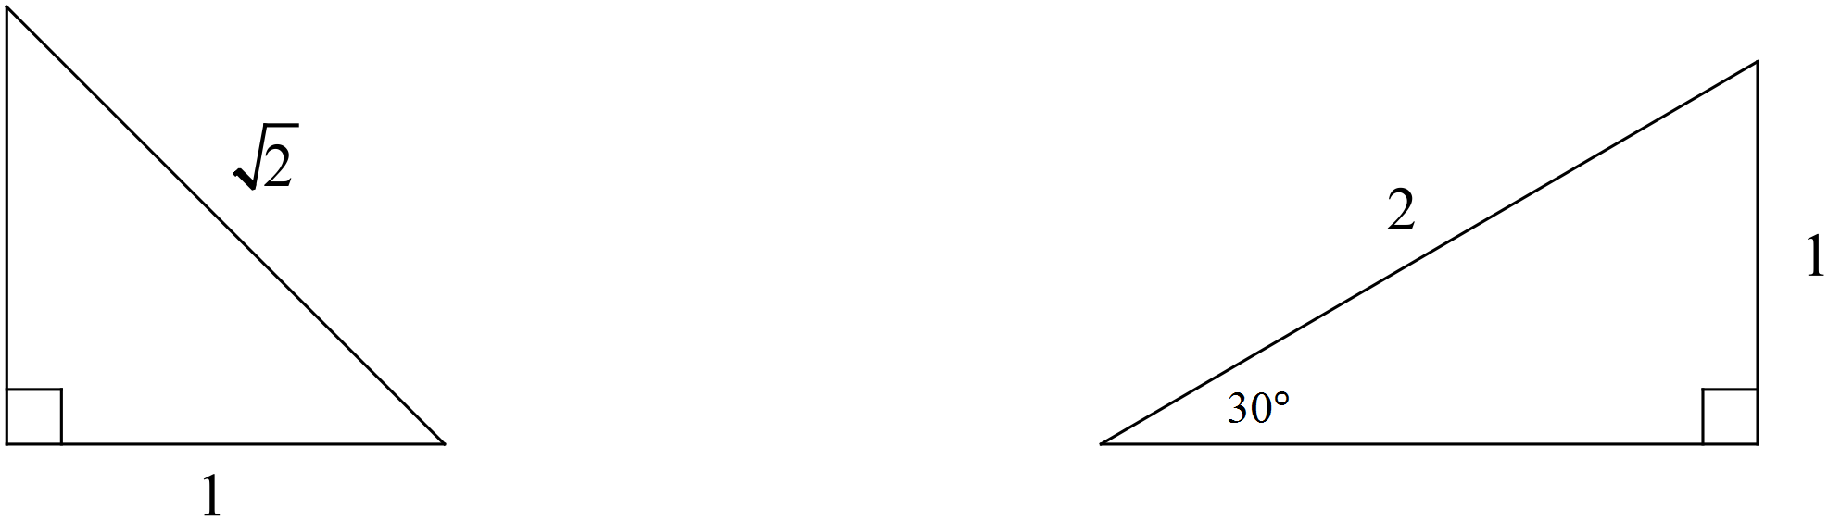

(a) Complete each triangle i.e. determine all the missing sides and angles. Write your answers on the diagrams above.

(b) Use your triangles to help you determine the **exact** value of(1 mark)

(i) sin 150°

(ii) cos 225°

(iii) θ , where tan θ =  for −180° ≤ θ ≤ 180°

**Question 2 [4 marks – 2, 2]**

Use the unit circle below to answer the questions that follow. Give your answers to an appropriate degree of accuracy.

 (a) Determine the value of sin 110°

(b) Solve for x

cos x° = −0.7 for 0° ≤ x ≤ 360°

**Question 3 [2 marks – 1, 1]**

Find the exact values of

1. cos 210o b) tan 

**Question 4 [2 marks – 1, 1]**

Consider the rule: y = 7 – 2 cos (.

1. Find the maximum value of the function y = 7 – 2 cos (.
2. Find the period of the function y = -4 tan(2πx)

**Question 5 [3 marks – 1, 1]**

The grid below shows a graph of y = cos(x) from 0 to 3π.

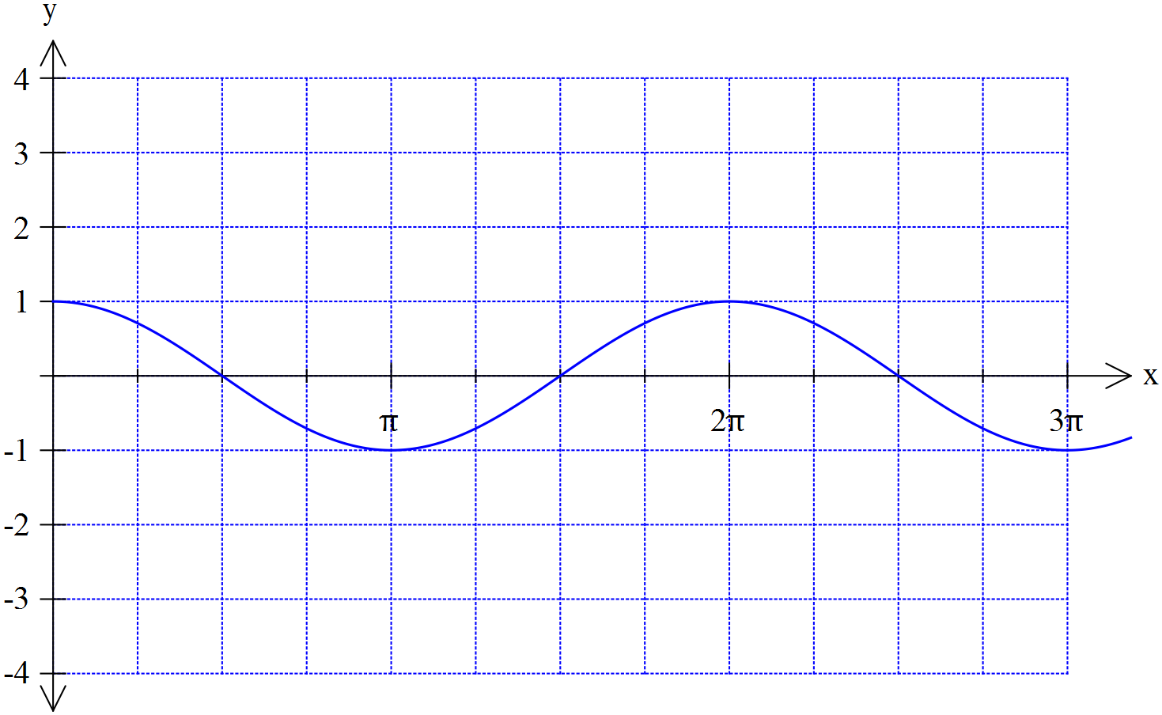

Plot the graph of y = -3 cos (2x) on the axes above

**Question 6 [4 marks]**

Find all solutions to the equation cos (2x) = 0.5 for the domain 0 ≤ x ≤ 360o

|  |  |
| --- | --- |
| EGC_Black | Student Name \_\_\_\_\_\_\_\_\_\_\_\_\_\_\_\_\_\_\_\_\_\_\_  **Eastern Goldfields College**  Mathematics Methods 2015  Test 311– Calculator Assumed Section |
| Working Time: 35 minutes | Total Marks: 29 marks |

**Question 7 [5 marks]**

Indicate which of the following represent functions with the letter **F**. For those that are functions, state the natural domain and corresponding range.

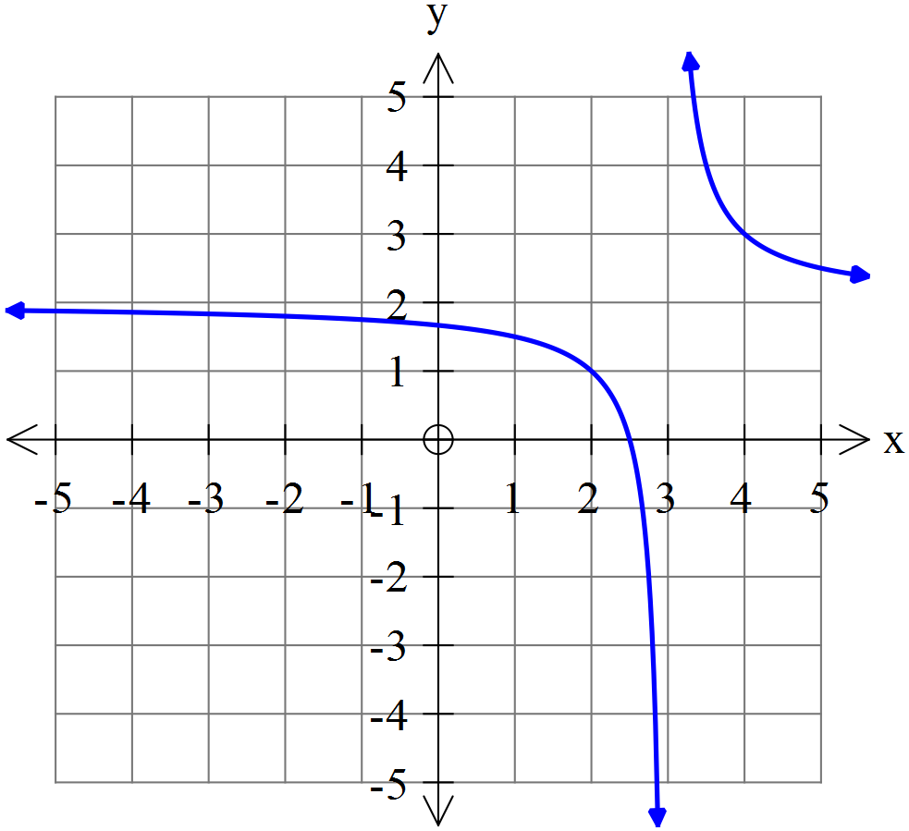 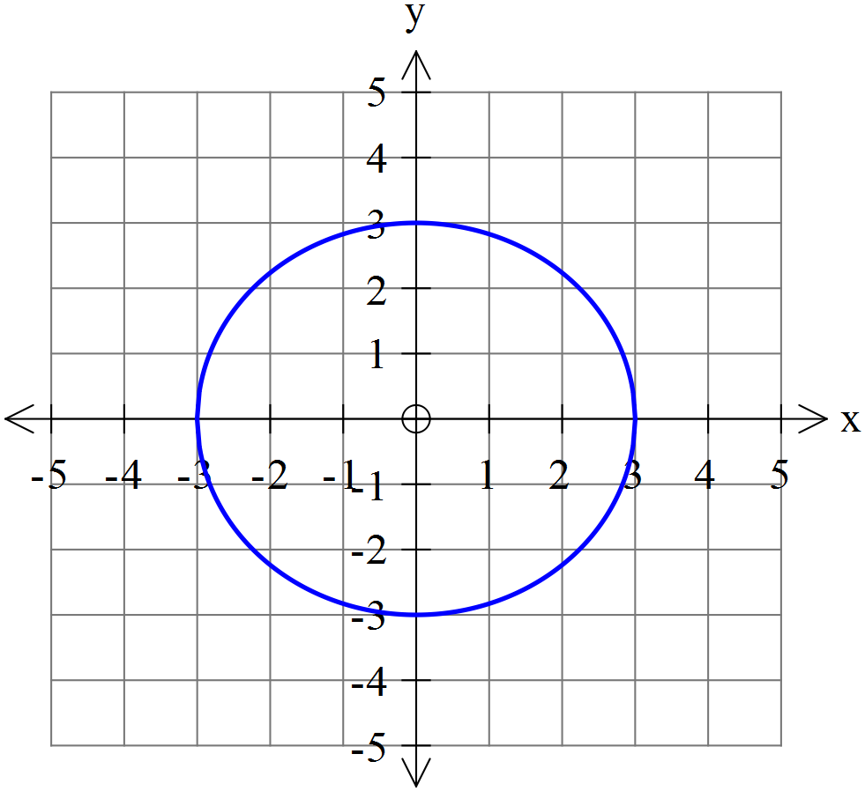 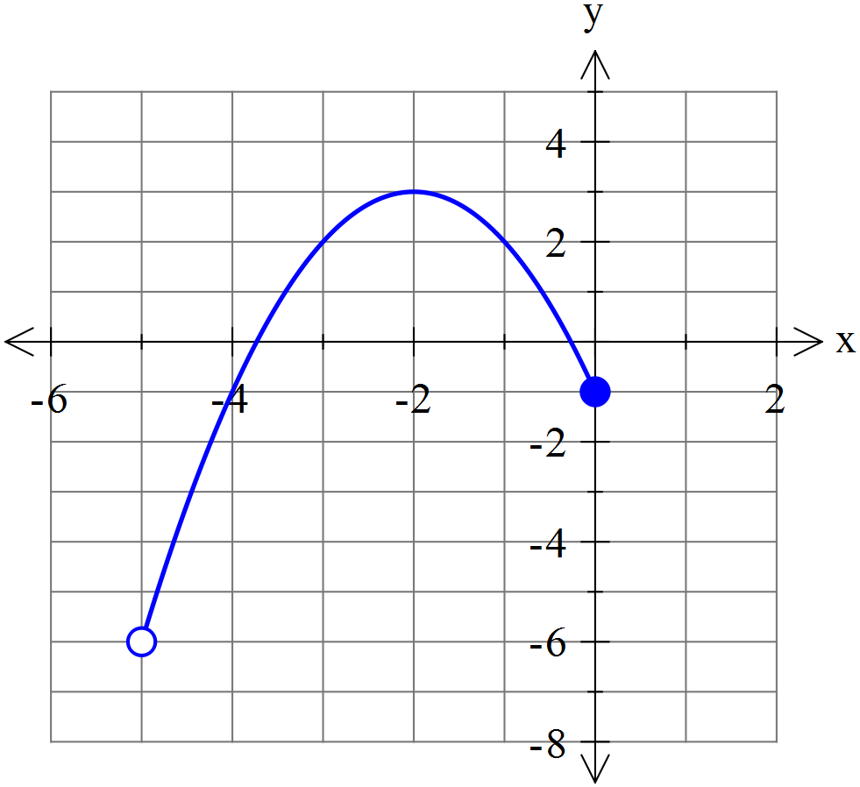

**Question 8 [8 marks – 2, 2, 2, 2]**

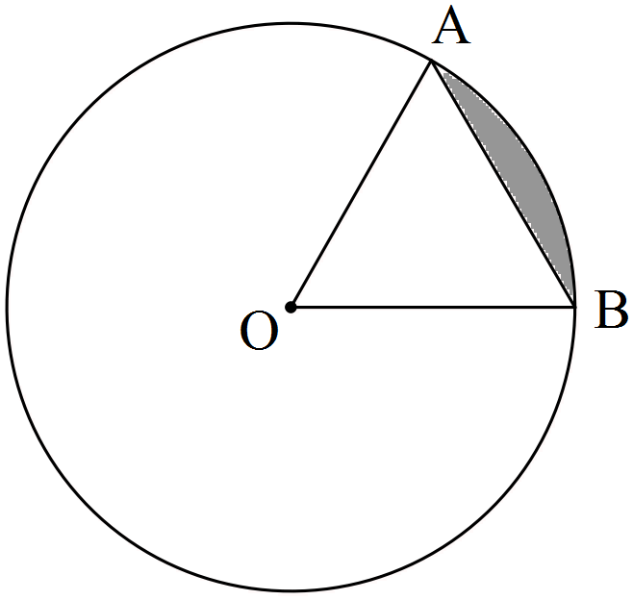

The circle shown with centre O has a radius of 3π cm.

If the size of ∠AOB = 60°, determine the

(a) area of triangle AOB as an **exact** value in terms of π.

(b) length of the ***major*** arc AB accurate to 2 decimal places.

(c) area of the ***minor*** sector AOB to the nearest cm2.

(d) area of the ***minor*** segment (shaded) formed by the chord AB accurate to 3 significant figures.

**Question 9 [5 marks]**

Triangle ABC drawn below has sides of 32 cm, 46 cm and 48 cm. The circle with a radius of 11 cm is inscribed inside the circle and just touches the three sides of the triangle.

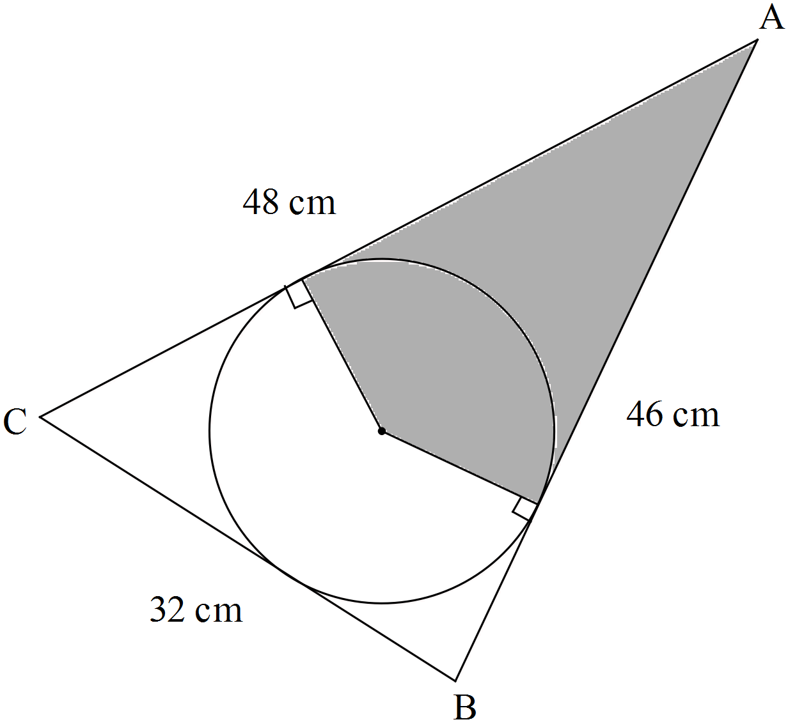

Note: Diagram not drawn to scale.

Determine the area of the shaded region. (Hint: First find the size of ∠BAC).

**Question 10 [4 marks – 2, 2]**

|  |  |
| --- | --- |
| Shown to the right is a graph of the function f(x)  Using your knowledge of transformations sketch the following. |  |

1. y = 2 f(x + 4) b) y = - f(-2x)

**Question 11 [7 marks – 2, 3, 2]**

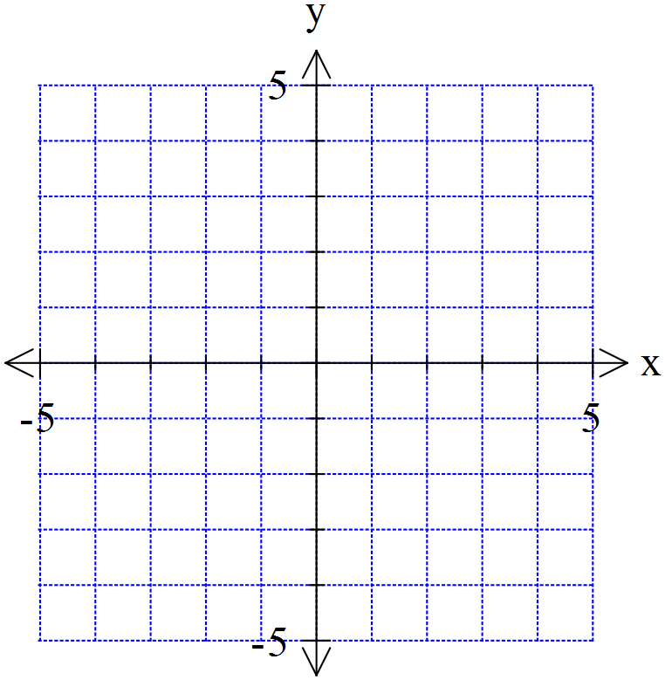



a) State the rule for a circle with a radius of with a centre of (-2,1).

b) Write the rule in the form x2 + y2 + dx + ey = f

1. Determine the distance from the closest point on the circle to the origin at (0,0)

